### Excel Evaluation Re-Exam [Advance][objective]

1. In the worksheet below, what do the symbols in rows 4, 6, 7, and 11 indicate?

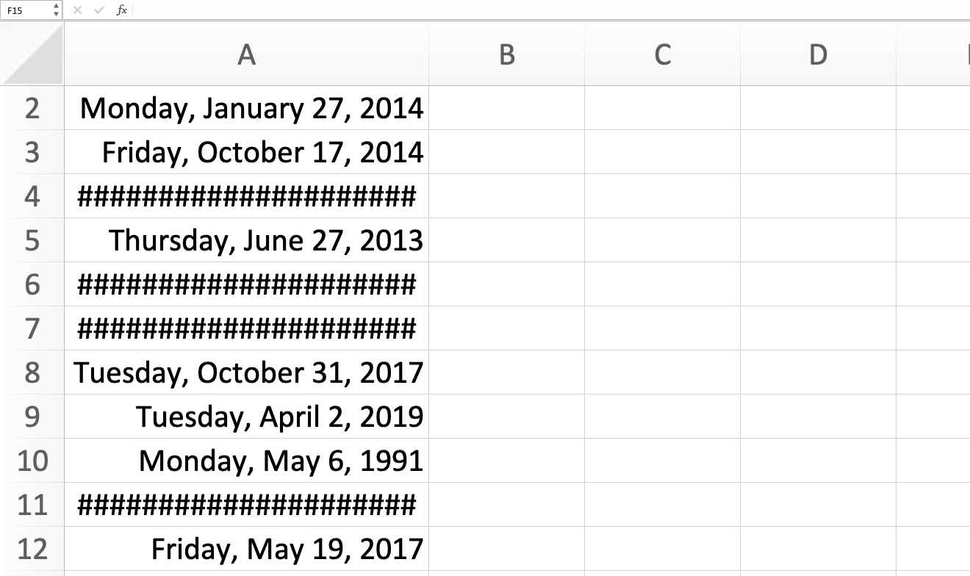

1. The dates are erroneous, such as October 39, 2015.
2. The columns aren't wide enough to show the full date.
3. The time are incorrectly formatted as dates.
4. The text is incorrectly formatted as dates.

2. What does the formula =SUM(A1:A10) do in Excel?

a) Adds the values in cells A1 through A10

b) Subtracts the values in cells A1 through A10

c) Multiplies the values in cells A1 through A10

d) Divides the values in cells A1 through A10

#### 3. How would you connect the slicer to both PivotTables?

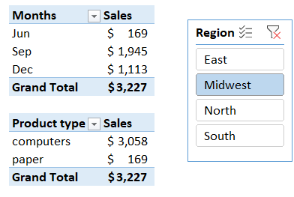

1. You cannot use one slicer for two PivotTables.
2. Right-click the slicer and select Slicer Settings.
3. Merge the two PivotTables, right-click the merged PivotTable, and select Combine Slicer.
4. Right-click the slicer and select Report Connections, or click Report Connections on the Slicer tab.

4. What feature can you use to populate B2:B7 with the number from each sentence in A2:A7?

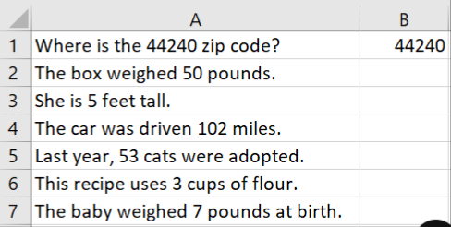

1. No Excel feature can accomplish this; this is possible only using formulas.
2. Flash Fill
3. Merge cells
4. Text to columns

5. In Excel, what is the keyboard shortcut to autofill a series?

* + A. Ctrl + F
  + B. Ctrl + A
  + C. Ctrl + E
  + D. Ctrl + R

6. What does the COUNTIF function do in Excel?

* + A. Counts the number of cells that meet a certain condition
  + B. Adds up all the numbers in a range of cells
  + C. Returns the average of a range of cells
  + D. Finds the highest value in a range of cells

7. Which Excel function would you use to calculate the future value of an investment based on constant, periodic payments and a constant interest rate?

a) PMT

b) FV

c) PV

d) NPER

8. What does the formula =SUM(A1:A10) do in Excel?

a) Adds the values in cells A1 through A10

b) Subtracts the values in cells A1 through A10

c) Multiplies the values in cells A1 through A10

d) Divides the values in cells A1 through A10

9. In Excel, what is the keyboard shortcut to autofill a series?

a) Ctrl + F

b) Ctrl + A

c) Ctrl + E

d) Ctrl + R

10. Which Excel feature would you use to prevent users from entering invalid data into a cell?

a) Data Validation

b) Conditional Formatting

c) Sparklines

d) Goal Seek

11. Which VLOOKUP function, when entered into cell L2 and then dragged to cell L5, returns the average number of calls for the representative IDs listed in column J?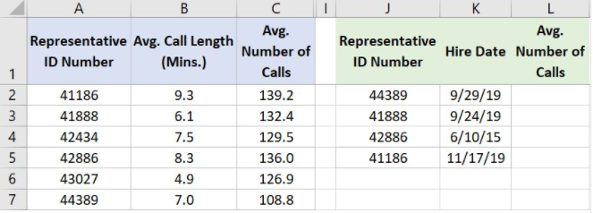

* a. =VLOOKUP(A2,J2:L5,1,FALSE)
* b. =VLOOKUP(J2,A$2:C$7,1,FALSE)
* c. =VLOOKUP(J2,A$2:C$7,3,FALSE)
* d. =VLOOKUP(J2,A2:C7,3,FALSE)

12. Which Excel tool allows you to filter PivotTable data dynamically based on specific criteria?

a) Slicer Tool

b) Filter Tool

c) Sort Tool

d) Subtotal Tool

13. Which function can be used to combine the functionality of VLOOKUP and HLOOKUP in Excel?

a) INDEX

b) MATCH

c) LOOKUP

d) TRANSPOSE

14. Which Excel feature allows you to create advanced calculations and data models using large datasets?

a) Power Pivot

b) Power Query

c) Power BI

d) Power View

15. What does the formula =TEXT(A1, "yyyy-mm-dd") do in Excel?

* + A. Converts a text string to a date
  + B. Checks if a date is in a specific format
  + C. Formats the date in cell A1 as "yyyy-mm-dd"
  + D. Extracts the year, month, and day from a date

16. What does the formula =MATCH("Apple", A1, 0) do in Excel?

* + A. Finds the position of "Apple" in the range A1
  + B. Counts the number of occurrences of "Apple" in the range A1
  + C. Replaces "Apple" with a value from the range A1
  + D. Checks if "Apple" is in the range A1

17. Which function would you use to calculate the average of a range of cells that meet a specific condition?

* + A. AVERAGE
  + B. SUMIF
  + C. AVERAGEIF
  + D. COUNTIF

18. What does the formula =LEFT("Hello World", 5) do in Excel?

* + A. Extracts the last 5 characters from the text string "Hello World"
  + B. Replaces the first 5 characters of the text string "Hello World" with "Left"
  + C. Extracts the first 5 characters from the text string "Hello World"
  + D. Converts the text string "Hello World" to uppercase

19. Which of the following functions would you use to round a number to a specified number of digits?

* + A. CEILING
  + B. ROUND
  + C. FLOOR
  + D. MROUND

20. Which of the following functions will return the number of characters in a text string?

* + A. SEARCH
  + B. FIND
  + C. LEN
  + D. LEFT

21. What does the INDEX function do in Excel?

* + A. Finds a value in a range based on its position
  + B. Returns a value or reference of the cell at the intersection of a particular row and column in a given range
  + C. Searches for a value in a range and returns the position of that value
  + D. Returns the maximum value in a range of cells

22. What is the purpose of the SUMPRODUCT function in Excel?

* + A. To multiply corresponding elements in given arrays and return the sum of those products
  + B. To sum a range of cells based on a condition
  + C. To multiply a range of cells by a constant
  + D. To find the product of a range of cells

23. You want to add a column to the PivotTable below that shows a 5% bonus for each sales rep. That data does not exists in the original data table. How can you do this without adding more data to the table?

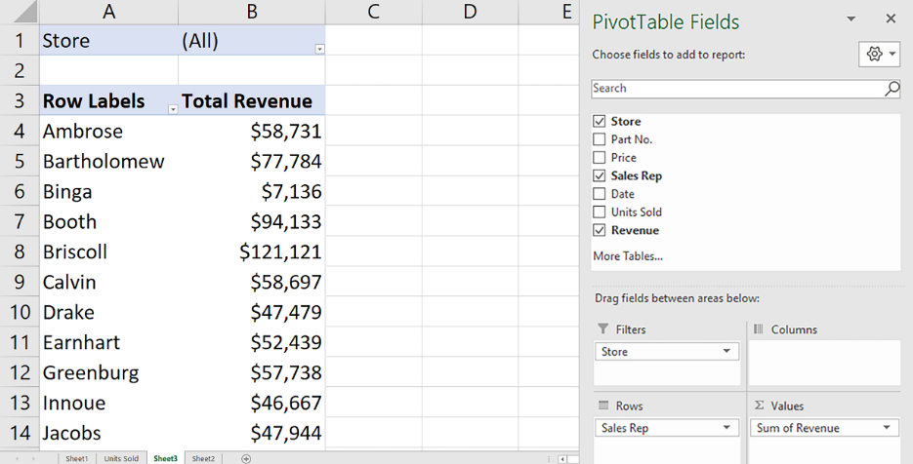

1. Add a new PivotTable field.
2. Add a calculated item
3. Add a new Summarize Value By field.
4. Add a calculated field.

24. Which value is returned when you enter this function into cell G2? =IF(SUM(F2:F6)>12,"Too Many Tardy Days","No Tardiness Issue")

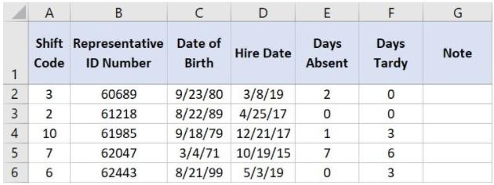

1. Too Many Tardy Days
2. #NUM!
3. No Tardiness Issue
4. #REF!

**25. What type of chart is this?**

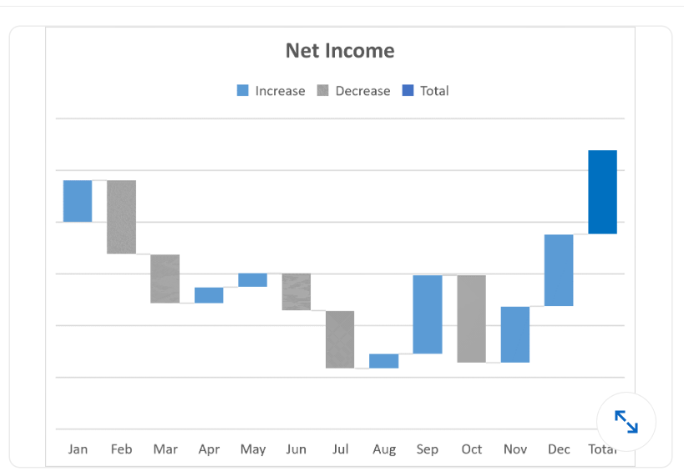

1. histogram
2. waterfall
3. Bar chart
4. box and whisker

15.c

16.a

17.C

18.C

19.B

20. c

21. B

22. a

23. d

24.c

25.b

1. b.) The columns aren't wide enough to show the full date.

2. a) Adds the values in cells A1 through A10

3. d) Right-click the slicer and select Report Connections, or click Report Connections on the Slicer tab.

4. b.) Flash Fill

5. D

6. A

7. b) FV

8. a) Adds the values in cells A1 through A10

9. d) Ctrl + R

10. a) Data Validation

11. c) =VLOOKUP(J2,A$2:C$7,3,FALSE)

12. a) Slicer Tool

13. a) INDEX

14. a) Power Pivot